Assignment Day -12

Task 1:-

**Create a dynamo db table with minimum two disaster recovery zones and verify replication.**

* First creating a table name songs with two columns Singer and Songs.
* Now adding a disaster recovery zone (Sydney).

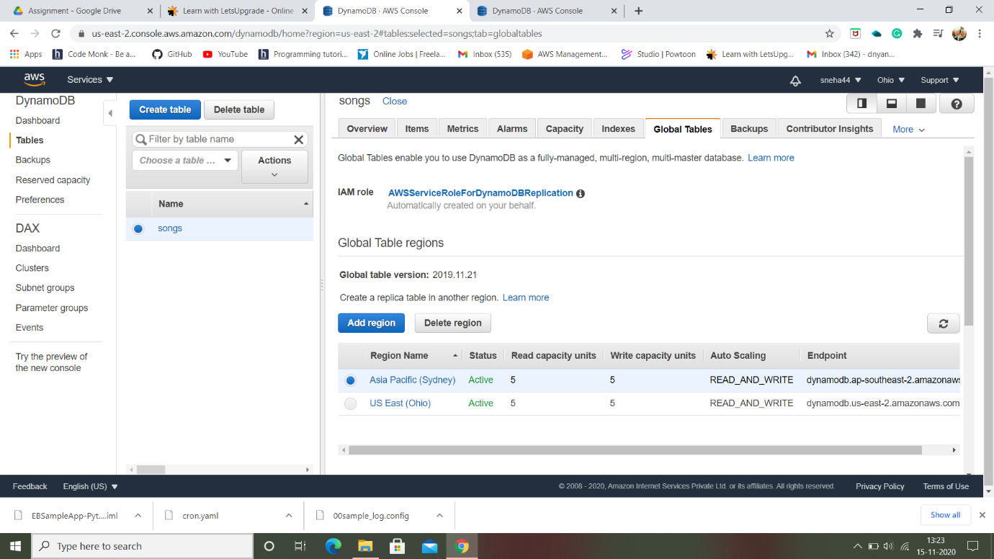

* Checking whether the same table is created in sydney region.

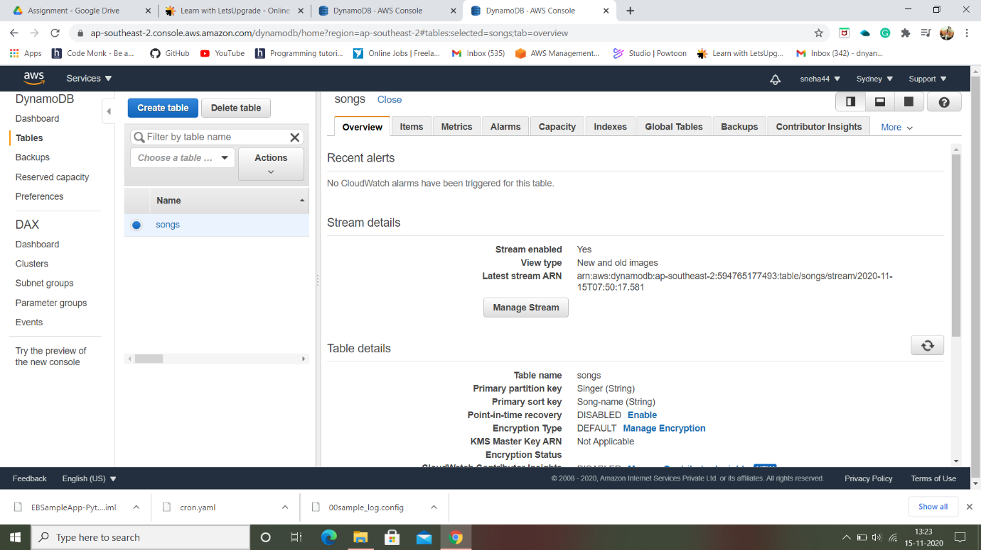

* Now creating one more zone named Singapore and verifying the same.

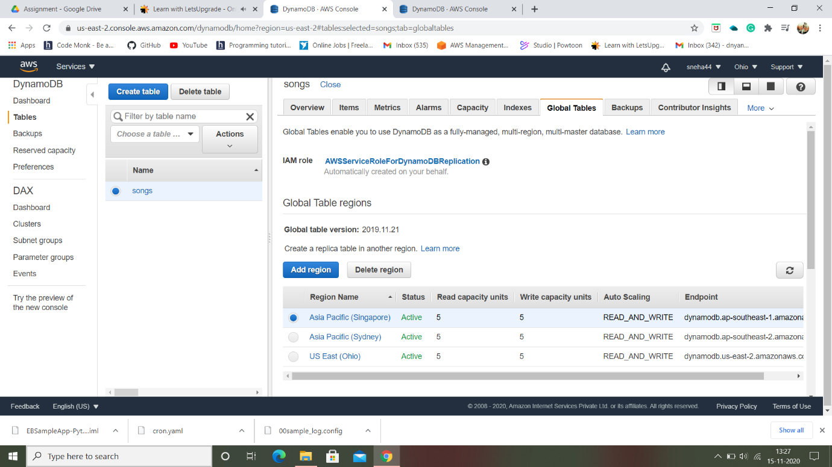

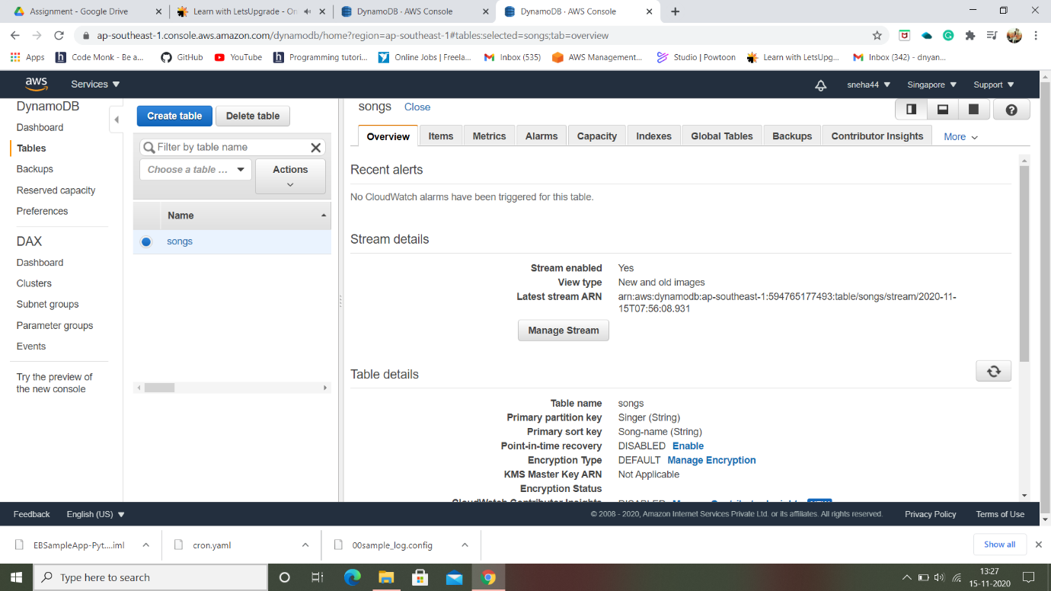

* Creating new items in a table.

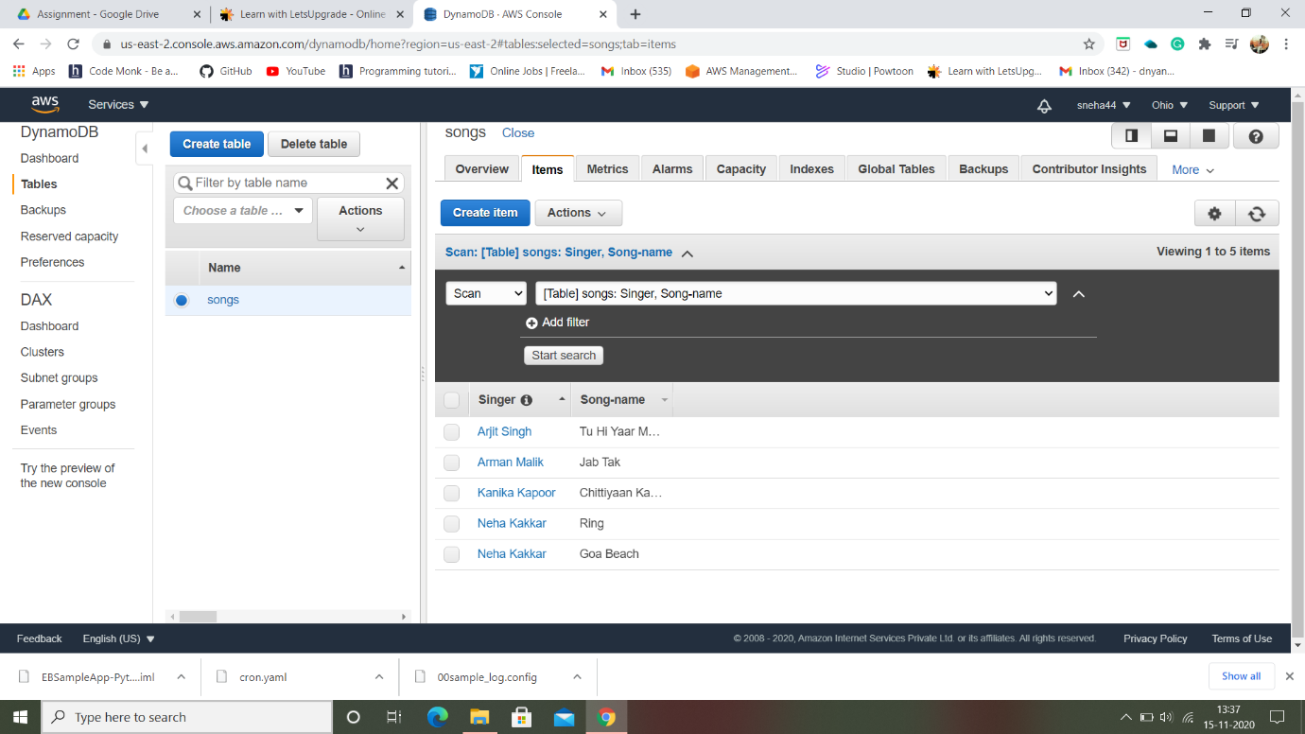

* Now checking whether rows are added to the table in other regions.

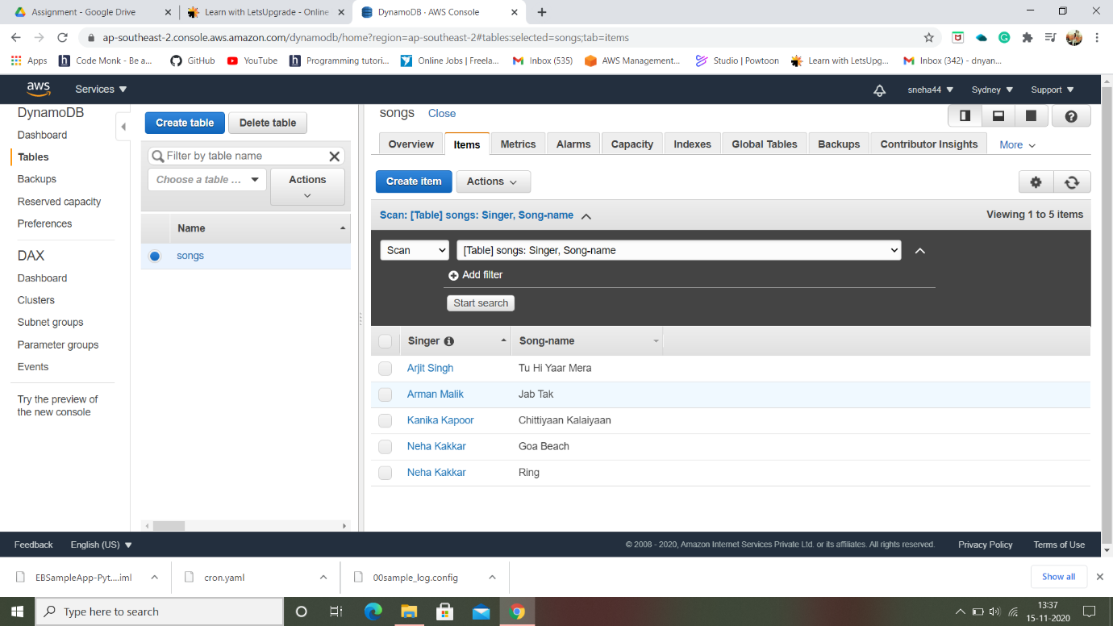

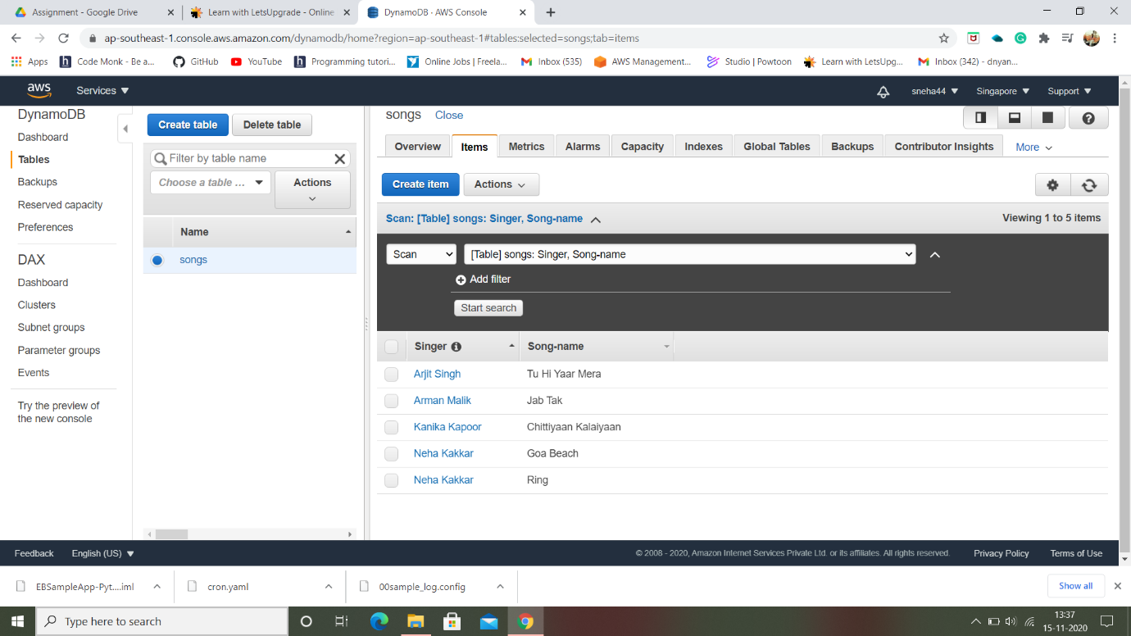

* Using filters (Query) and checking whether it reflects in other regions.

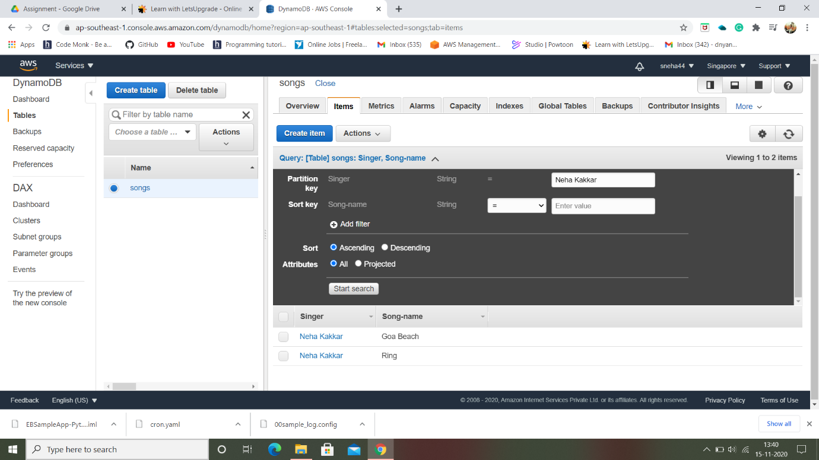

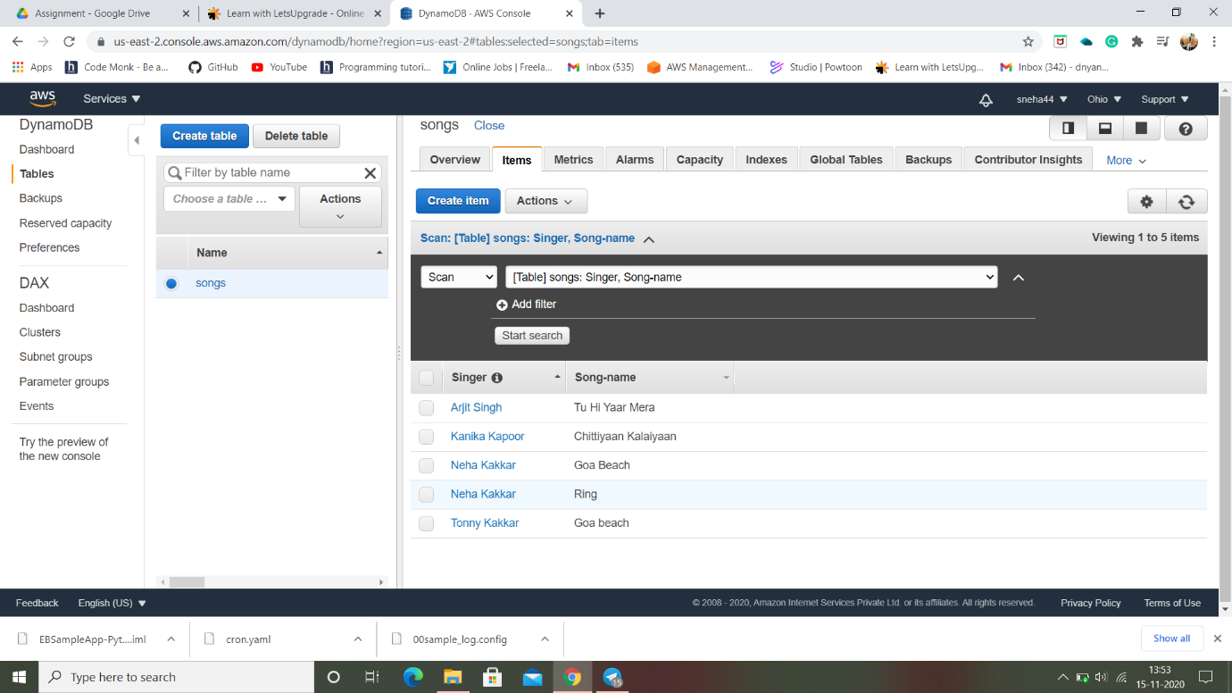

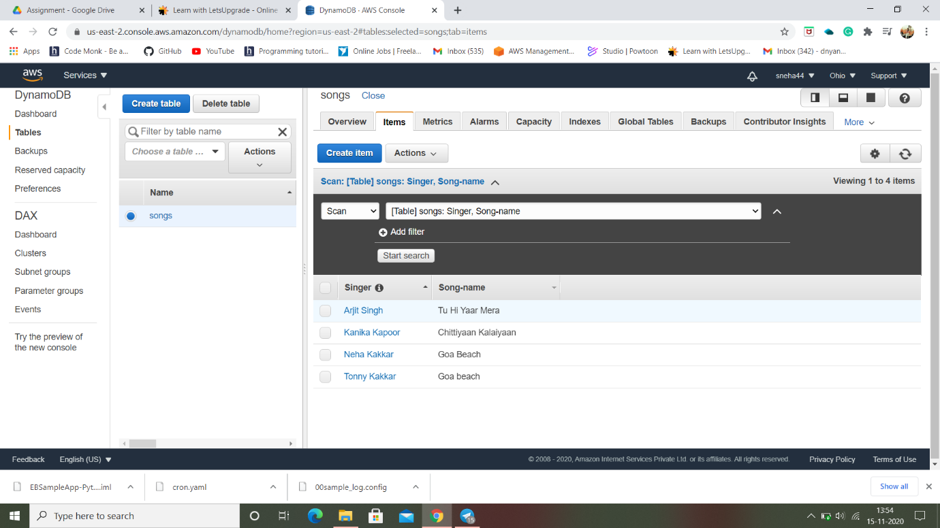

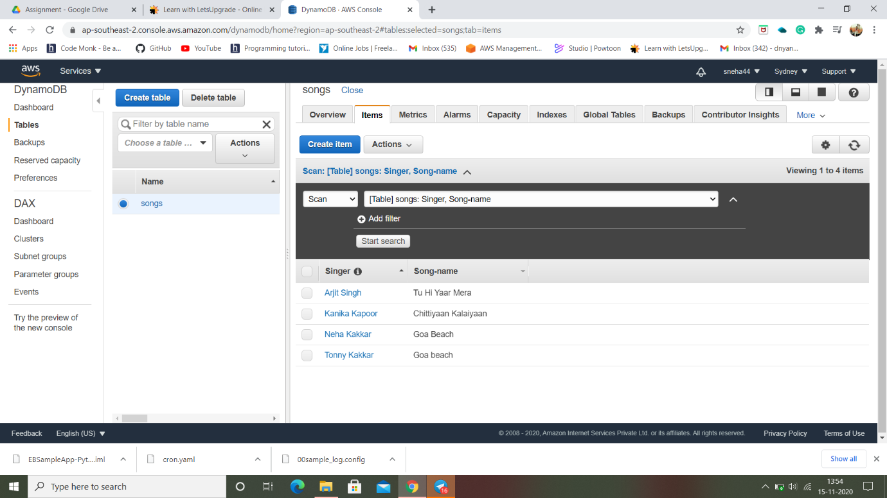

Task 2:-

**Creating a dynamo DB table with global secondary indexes and fetching data using global secondary indexes.**

* Creating new table named Employee.

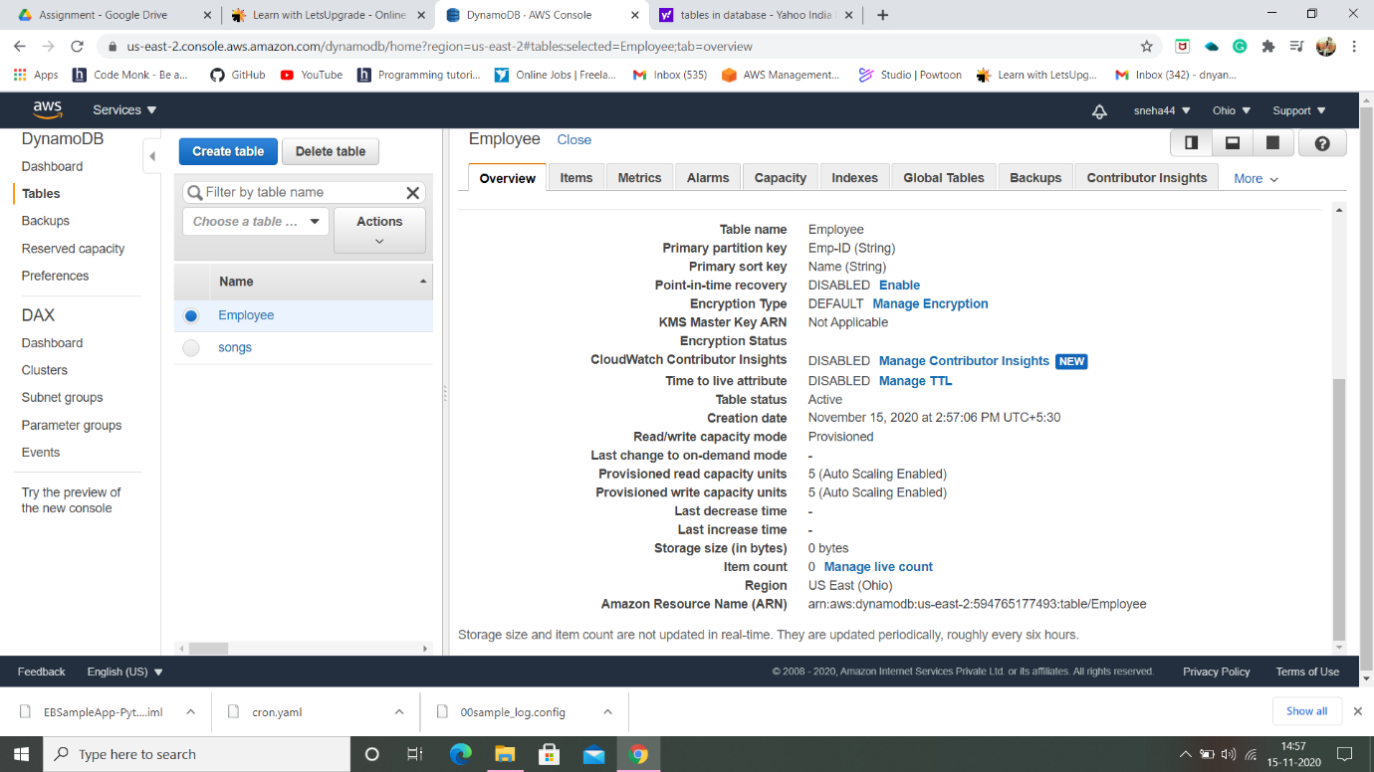

* Some entries of items.

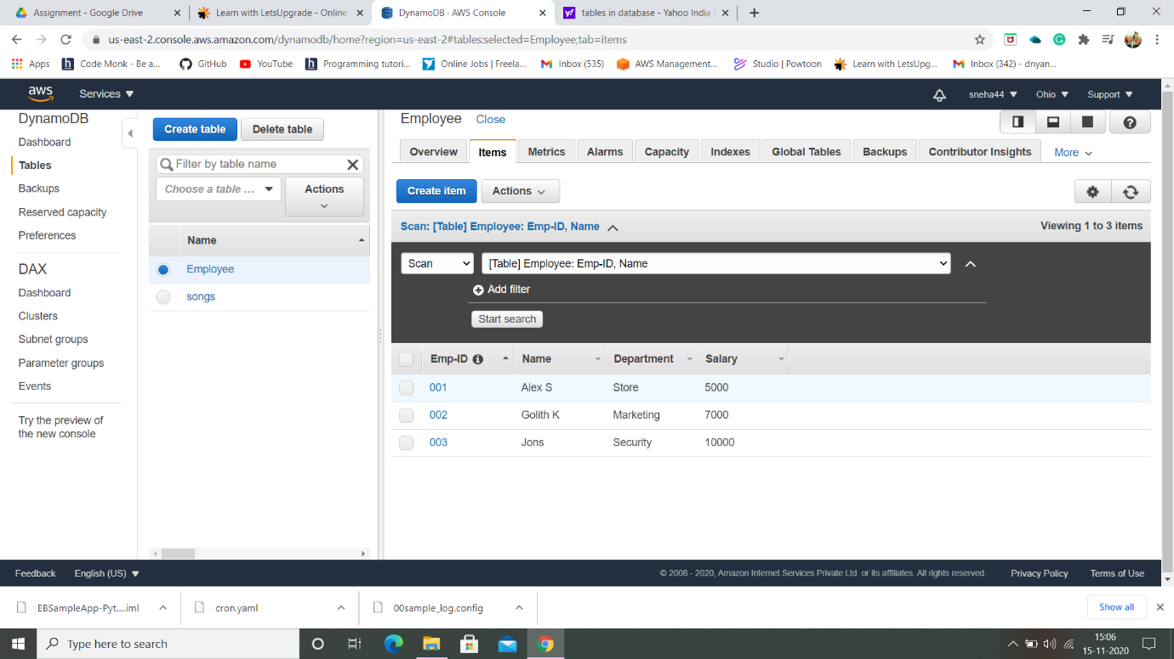

* Creating a Global Secondary Index with Emp-ID as partition key and Salary as sorted key:

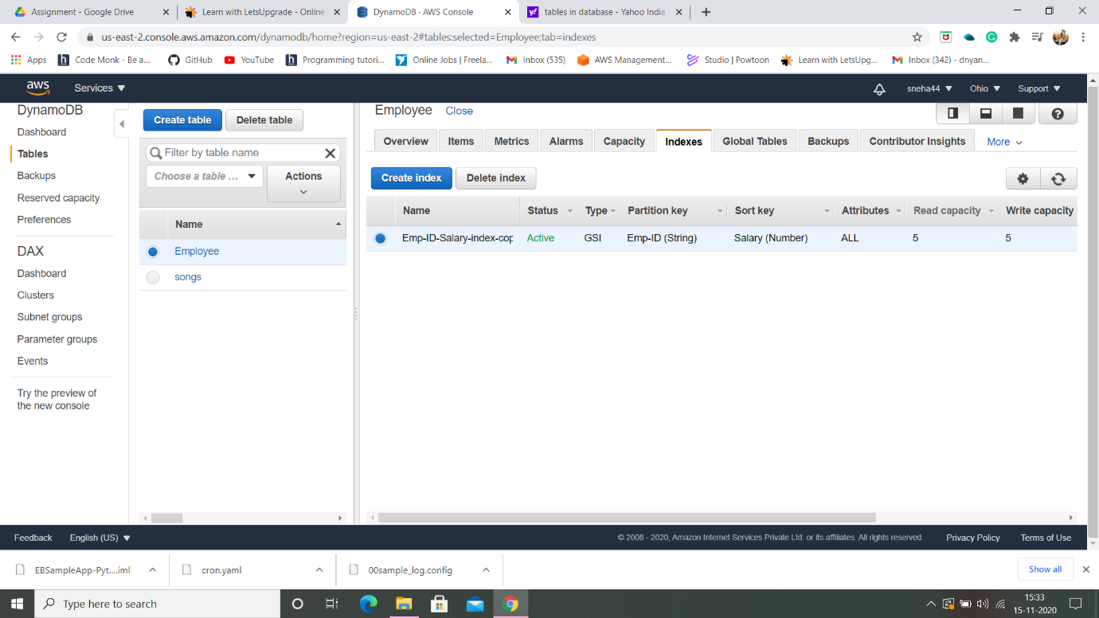

* Scan with Global Secondary Index.

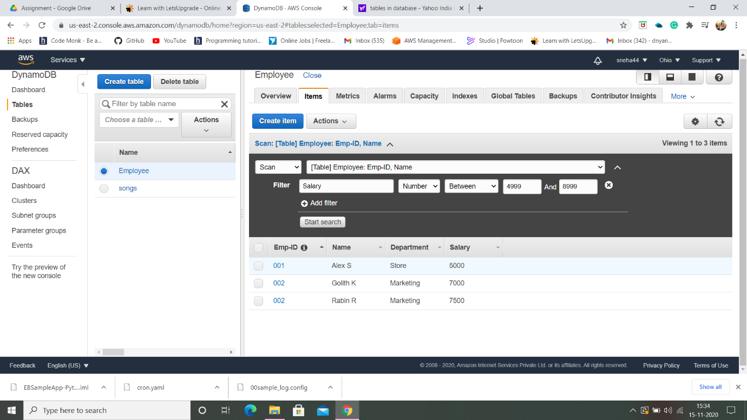

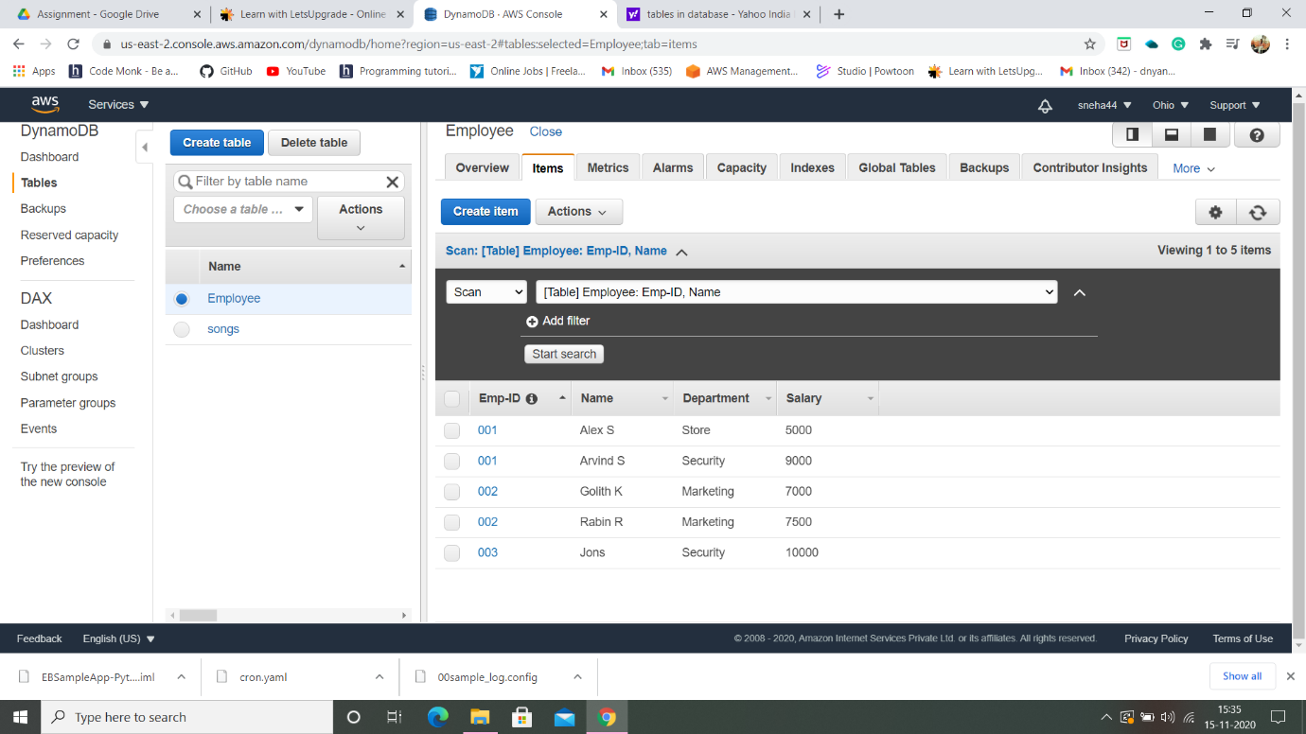

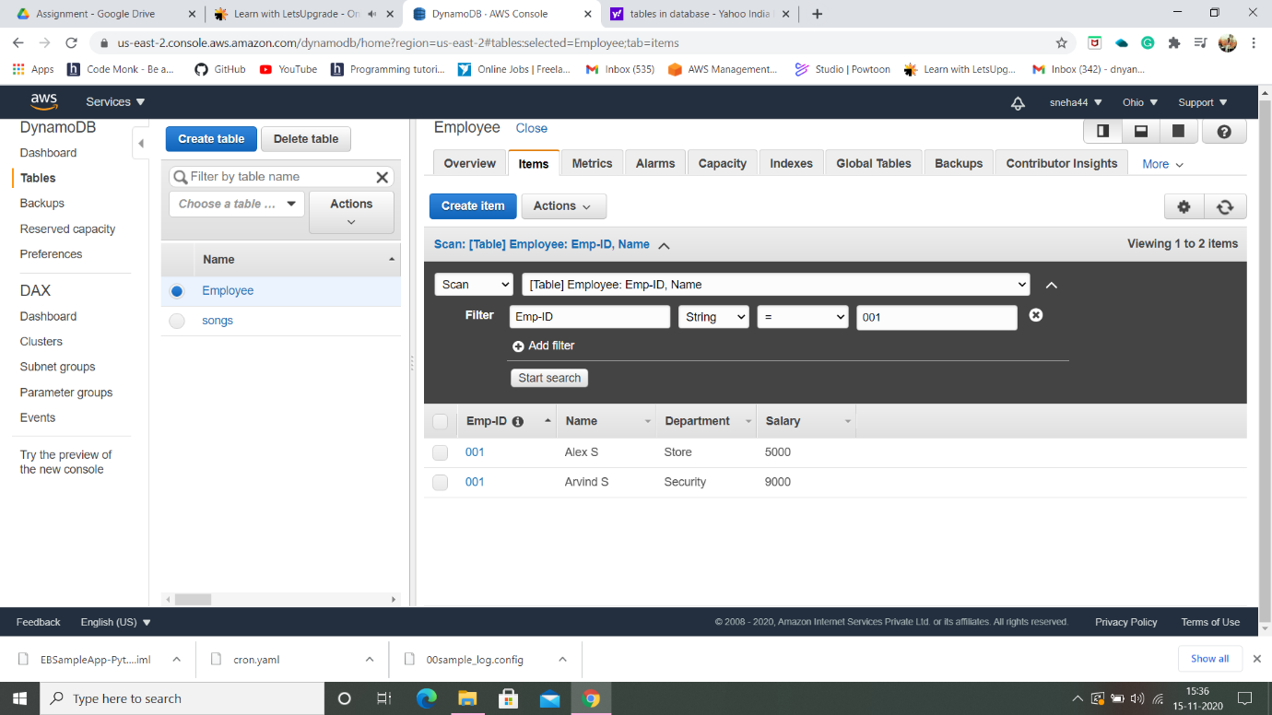

Task 3:- **Deploying a python application in elastic beanstalk:**

* Creating an application.

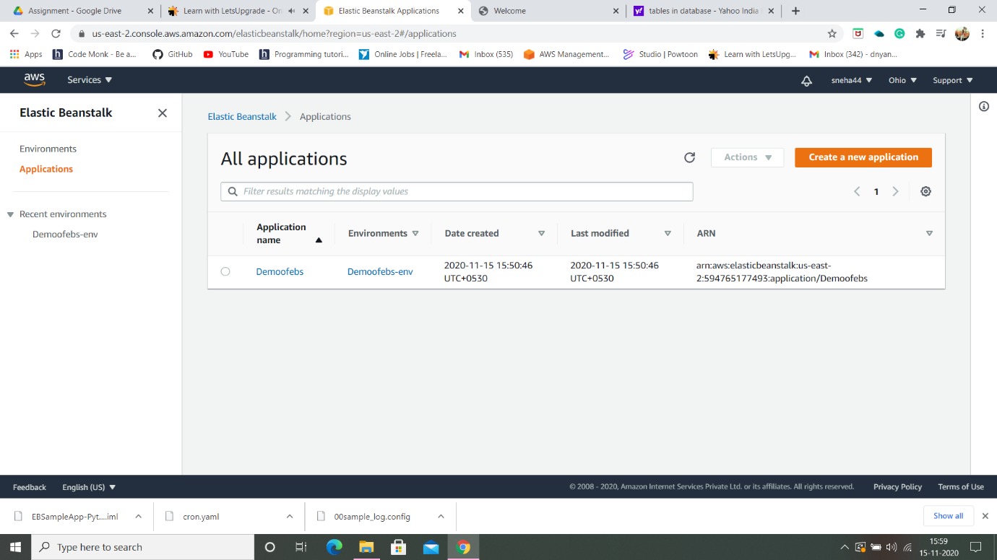

* Environment List page.

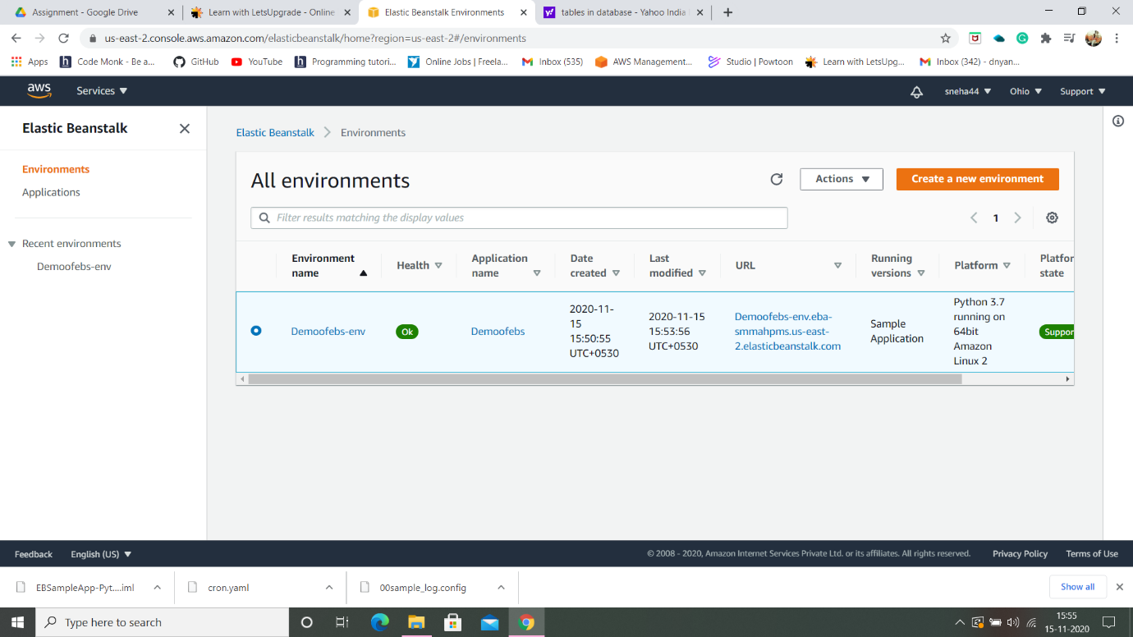

* Environment Health check of Application.

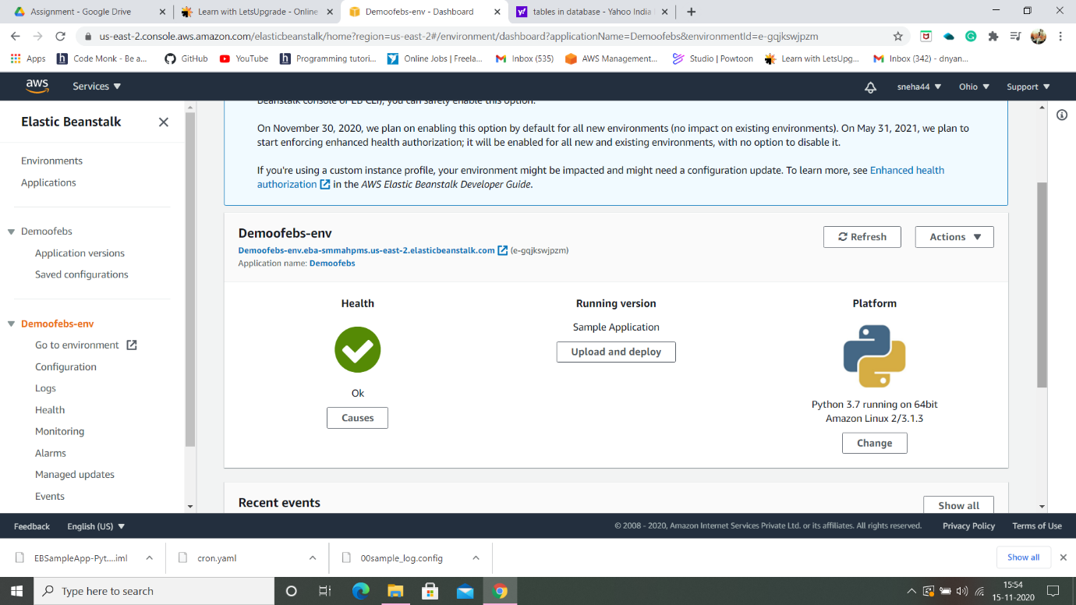

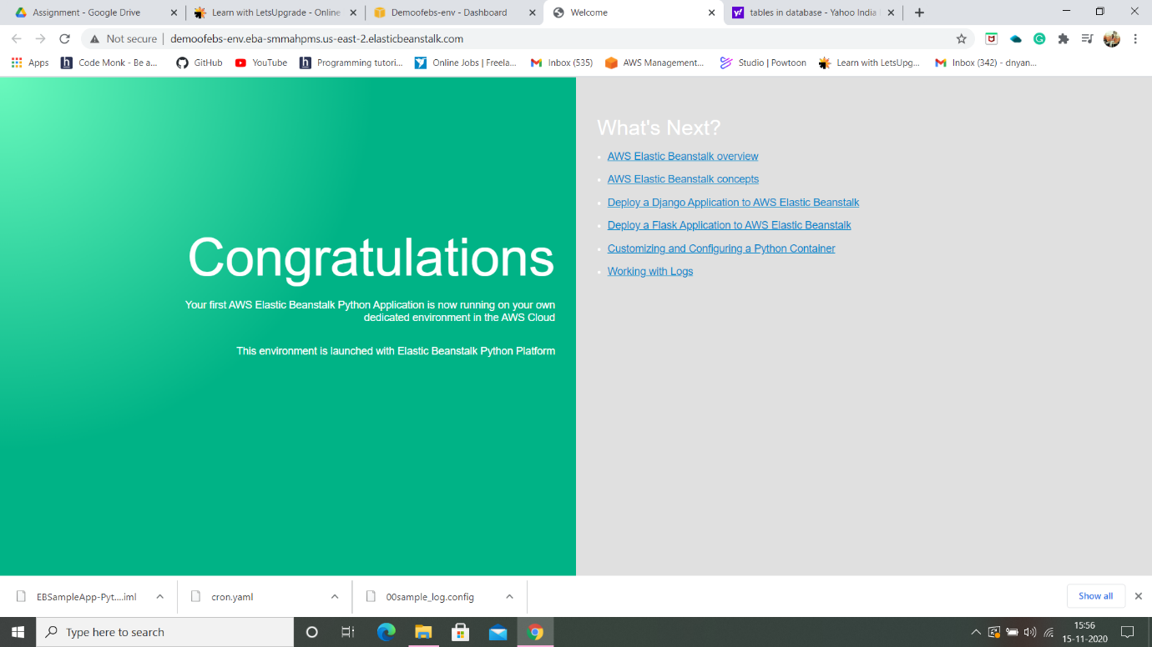

* When python application is created, a default instance is created.

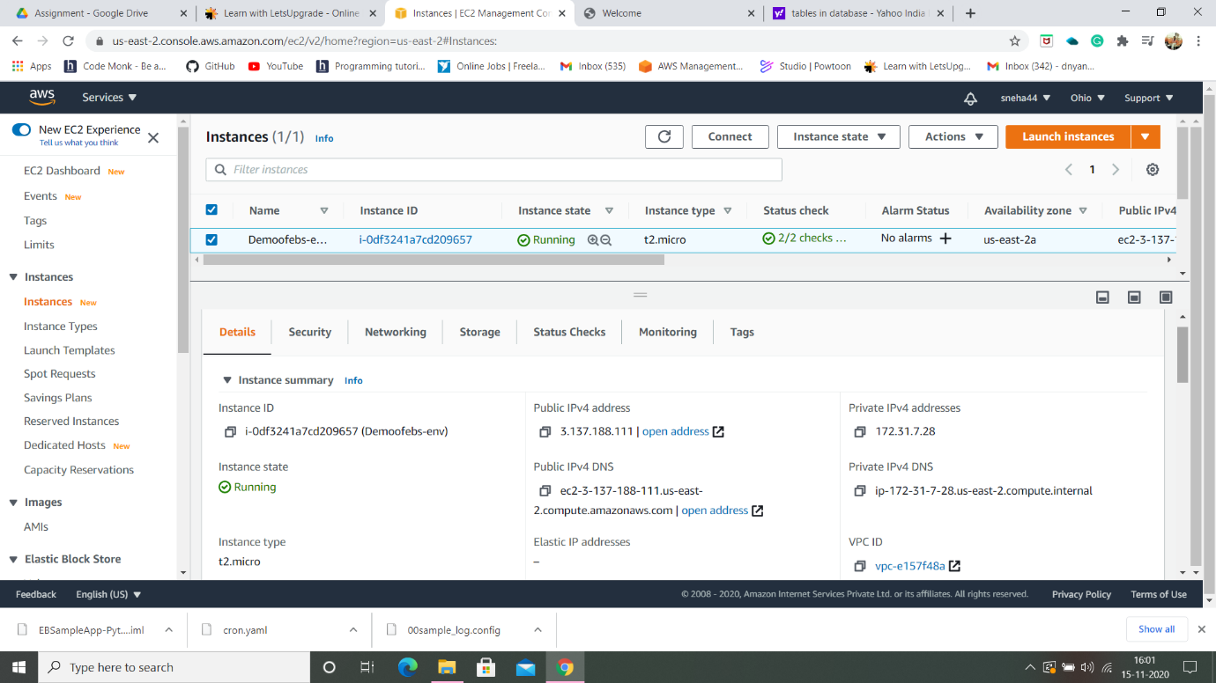

**---THE END---**